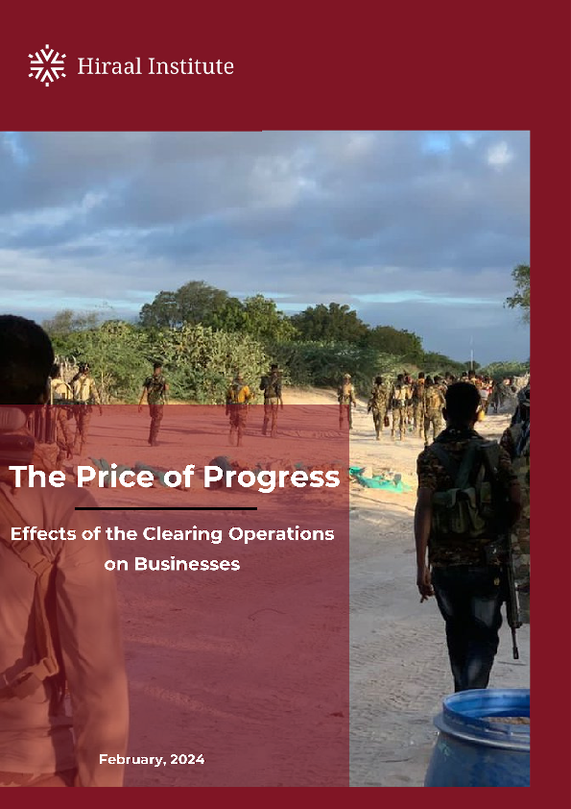

Table of Contents
Executive Summary 1
1. Introduction 2
2. Research Methodology 3
3. Background of the Clearing Operations and Its Implications 3
3.1 Insights and Testimonials from Survey Respondents 4
4. Challenges and Disruptions to Businesses 5
4.1 Banking Sector 6
4.2 Telecommunications Sector 7
4.3 Al-Shabab and IS-Somalia attacks on businesses 9
4.4 Wider Economic Consequences and Risk Analysis 11
4.5 Extortion Practices in Liberated Areas: Analyzing the Checkpoint Phenomenon 12
5. Conclusion 13
5.1 Recommendations 14

Executive Summary
This report offers an analytical assessment of the impact of the 18-month long clearing operations on businesses in Somalia. It draws on survey responses from over 100 professionals in the banking, telecommunications, transportation, and shipping industries operating in areas affected by military operations against Al-Shabab.
Clearing operations cause substantial disruption to business activities, incurring increased costs, service disruptions, and physical damage. Prominent among these disruptions is the notable impact on Hormuud, Somalia's leading telecom provider. Eight of Hormuud's transmitter towers were destroyed by government forces and allied factions, leading to substantial economic burdens and service disruptions. Furthermore, the enforced shutdown of 22 Hormuud sites by Al-Shabab highlights the use of telecommunications infrastructure for political coercion.
In the banking sector, operations have been seriously disrupted with extortion and corruption threatening institutional stability and undermining the sector. Extortion practices by both Al-Shabab and government officials amplify the challenges businesses face, further eroding public trust in institutions.
The broader economic consequences of these challenges include the potential for capital flight, strained public finances, and reduced tax revenues. These impacts, combined with the erosion of public trust and challenges faced by businesses in adapting and expanding, pose significant threats to Somalia's long-term growth prospects.
Moreover, the clearing operations, while aimed at enhancing security, inadvertently undermine stabilization efforts in newly liberated areas. The resultant disruptions to business operations not only impose immediate economic costs but also foster an environment of uncertainty and insecurity, which can stifle efforts towards sustainable development and peace-building.
The report proposes recommendations to address these challenges. Strengthening anti-corruption measures, establishing supportive mechanisms, enhancing security measures, fostering public-private partnerships, developing risk mitigation strategies, investing in infrastructure and services, prioritizing capacity building, and seeking international support are all essential steps to mitigate the negative impact of the clearing operations.
Close collaboration between the government, businesses, and international stakeholders is fundamental to overcoming challenges and harnessing the opportunities that arise in the post-clearing operation phase. Ultimately, it is imperative for Somalia to address these challenges and risks, safeguard the integrity of its banking and telecommunications sectors, and lay a robust foundation for economic resilience and sustainable development.

1. Introduction
In August 2022, the Somali government embarked on Phase 1 of an extensive series of clearing operations, primarily catalysed by localised uprisings against Al-Shabab in the Hiran province. The resultant military push has since been successful in eliminating much of the Al-Shabab influence in eastern Hiran and Middle Shabelle, with current operations ongoing in the Galgaduud and Mudug regions.
The battle, however, extends beyond military confrontations, permeating the spheres of legal and policy reform. In March 2023, a contentious counterterrorism bill was enacted, laden with vague language that has raised concerns over the potential for misuse against journalistic reporting.
While the implications of these measures on national security are frequently discussed, their impact on Somalia's economic sectors, particularly banking and telecommunications, has been less scrutinized. This study aims to fill this gap by examining the repercussions of both the military operations and the new legislative framework on these industries. Drawing on confidential interviews with industry professionals, who shared their experiences anonymously due to security concerns, this article uncovers a range of challenges faced by businesses. These include not only the direct consequences of infrastructure damage and service interruptions but also the indirect effects of increasing corruption and extortion within the context of these operations.
This study focuses on the operational hurdles encountered by businesses, their strategies for overcoming these challenges, and the role of the Somali government in either facilitating or hindering their efforts. Additionally, it contemplates the future of these industries post-operation, evaluating potential risks and opportunities as well as the anticipated impact on the local economy and employment levels.
Moreover, this article critically assesses how these developments could undermine efforts to stabilize newly liberated areas, potentially exacerbating the fragile security situation and hindering progress towards peace and economic recovery.
The findings of this exploration contribute to our understanding of the effects of conflict and counterterrorism measures on Somalia's economy, offering valuable insights to inform policy decisions. Further research is crucial to navigate the complex intersection of conflict, policy, and business operations.

2. Research Methodology
The findings and analysis presented in this report are based on primary research conducted from May to August 2023 involving in-depth interviews with professionals from key business sectors in Somalia. We interviewed over 100 officials from various companies in the transportation, banking, telecommunications, and shipping industries across south and central Somalia. The sample focused particularly on professionals operating in regions impacted by clearing operations against Al-Shabab.
The semi-structured interviews focused on gaining firsthand insights into the operational challenges these business sectors face due to the clearing operations. Questions probed the nature of disruptions experienced, increased costs incurred, extortion practices witnessed, and strategies employed to mitigate difficulties.
Interview responses were documented through notetaking and audio recordings for further analysis. The findings derived from these interviews with officials on the ground dealing with the direct impacts of clearing operations provided critical perspectives. Key quotes, facts, and insights obtained from the interviews have been integrated throughout the report to substantiate the analysis on topics ranging from infrastructure damage to service disruptions, arbitrary arrests, and corruption.
The methodology employed in this study aimed to lend an evidence-based, primary research dimension to our exploration of how clearing operations are impacting businesses in Somalia. Further ongoing research through continued business community engagement will prove vital as this complex situation evolves.

3. Background of the Clearing Operations and Its Implications
The clearing operations in central Somalia are part of a broader counter-insurgency strategy against Al-Shabab, an extremist group that has long challenged the nation's peace and stability. The main purpose of these operations is to displace the group's hold on the Federal Member States (FMSs) of GalMudug, HirShabelle, Southwest, and Jubaland, in order to establish or restore governmental control and subsequently facilitate the provision of services, development activities, and the rule of law. The operations have been stuck in Phase 1 since August 2022, with Phase 2 unlikely to begin anytime soon. Phase 1 of the operations are meant to clear Al-Shabab of GalMudug and HirShabelle, north of the Shabelle River. This has proven difficult for the government: control of territory has seesawed between Al-Shabab and the government.
Clearing operations in conflict zones have far-reaching implications spanning various sectors. On the positive side, these operations can lead to enhanced security, a more stable operating environment for businesses, and an opportunity for development initiatives. Once areas are cleared of hostile elements, they are often safer for residents and can better attract investments, which can spur economic growth.
However, these operations also have significant short- to medium-term negative impacts, particularly during the active phase of conflict. Businesses operating in these areas often face numerous operational challenges, including increased costs, disruption of services, and the risk of physical damage. Moreover, the uncertainty and instability associated with clearing operations can deter investment and inhibit economic activities.
A critical and often overlooked implication pertains to the potential misuse of power during clearing operations. In the Somali context, there have been allegations of government officials exploiting the chaotic situation to extort money from businesses, often under the guise of 'operational necessities'. Such actions erode trust in public institutions, thus exacerbating the challenges businesses face in these trying times.
In the next sections, we delve into the specific impacts of these operations on Somalia's business community, informed by our survey findings from industry professionals operating in these areas.

3.1 Insights and Testimonials from Survey Respondents
Drawing on the first-hand accounts of professionals in the business sectors, this section captures a detailed portrayal of the impact of clearing operations, the pervasive issue of extortion, and the operational challenges facing businesses in the liberated areas of Somalia.
A. Impact of Clearing Operations on Businesses
Respondents rated the impact of clearing operations on their businesses as an 8 out of 10, indicating a high level of disruption. They further detailed how these operations led to situations where services had to be shut down, disrupting critical services such as electronic money transfers.
One respondent gave a vivid description of how clearing operations led to increased instances of employee arrests and directives to provide services beyond their capacity. They also mentioned the challenge of conflicting orders from different authorities, stating, "The most common challenges we have seen are arresting employees without reason, being asked for a service that we cannot provide, and conflicting orders from different officials."
B. Prevalence and Impact of Extortion
When asked about their experiences with extortion, one respondent shared, "We have encountered it several times; we have also been mistreated by the administration and security officers; they ask us to pay money to continue our services, sometimes they physically assault us to force us to pay a bribe."
The pervasiveness of extortion is further captured in another comment: "Yes, the operations have made it easier to pay bribes because the service is stopped for a long time and that stops the business and finally there is a way to take bribes, this is a common issue that we have seen many times."
C. Lack of Supportive Measures
One notable recurring theme in the survey responses is the lack of mechanisms in place to protect businesses from corruption and extortion. "There are no specific measures to prevent such actions, but what steps we can take, we will take," stated one respondent. Another respondent echoed this, saying, "We do not have a clear strategy to prevent corruption during the operations, only to make contacts with the higher authorities when an obstacle arises, and it is possible that they solve it and sometimes you will have to solve it yourself [by paying a bribe]."
The absence of government support was a shared sentiment among the respondents, with one participant stating, "There is no dedicated government support mechanism for us in activities like banking and telecommunications, we are among the most affected business people.”

4. Challenges and Disruptions to Businesses
The survey responses paint a nuanced picture of the ways in which clearing operations are impacting businesses in Somalia. As the Somali government advances its campaign against Al-Shabab, businesses, especially those in the banking and telecommunications sectors, have been thrust into a complex environment that poses significant operational challenges.
In terms of quantifying the effect of these operations, businesses provided an average rating of 8 out of 10, which indicates a high level of disruption. This disruption manifests in various ways, which often converge to create a challenging business landscape.
One recurrent theme from the responses was the issue of conflicting operational orders. Businesses are caught in a web of directives from different authorities, resulting in confusion and operational inefficiency. This not only stunts business growth but also creates an uncertain business environment that makes strategic planning and forecasting difficult.
Additionally, businesses reported being asked to provide services they couldn't deliver. The situation is exacerbated when the requests are coupled with threats or ultimatums, often leading to heightened tension and a strain on resources. Perhaps most disturbingly, businesses reported arbitrary arrests of their employees. This not only deprives businesses of much-needed human resources but also instills fear and uncertainty among remaining staff. The arbitrary nature of these arrests implies a lack of due process and a disregard for the rule of law, creating a hostile environment for businesses.
The ability of businesses to service their customers has also been significantly affected by the clearing operations. In certain instances, they were forced to turn off their systems, disrupting essential services and negatively impacting customer satisfaction and trust.
While the clearing operations may be achieving their security goals, they present a series of challenges for businesses operating in the affected areas. The operational challenges faced by businesses not only signify a high level of disruption but also critically undermine the stabilization efforts in newly liberated areas. The prevailing uncertainty, compounded by conflicting directives and the arbitrary treatment of employees, erodes the foundation for sustainable economic recovery and growth. Such an environment is counterproductive to fostering a sense of security and normalcy, essential for the successful stabilization and revitalization of these regions.
Without adequate measures to mitigate these challenges, the potential for economic growth and development in these areas may be compromised. The following sections will delve into more specific impacts on the banking and telecommunications sectors and highlight instances of extortion and corruption experienced by businesses.

4.1 Banking Sector
Somalia's banking sector, a fundamental pillar of the country's economy, is grappling with significant disruptions due to threats and actions initiated by Al-Shabab. In particular, the intent expressed by Al-Shabab to retaliate against banks following the government's decision to sanction potential AS-linked accounts serves to illustrate the intricate and diverse economic consequences of these operations.
The warning issued by Al-Shabab spokesman Ali Dhere in January 2023 exemplifies these complications. Dhere admonished domestic and foreign banks operating within Somalia, accusing them of violating the trust of the Muslim population by adhering to international regulatory norms. This criticism signals a marked escalation in tensions, fostering an atmosphere of insecurity for banking institutions within the country.
The impact of such threats extends beyond the immediate banking sphere, permeating throughout the entire economic landscape of south and central Somalia. The significant role financial institutions play in facilitating transactions, extending credit, and ensuring economic stability implies that any destabilization within the banking sector may cause substantial reverberations within the broader economy. The threat against banks has the potential to undermine depositor and investor confidence, possibly inciting a liquidity crisis that could further strain Somalia's already precarious economic situation.
Dhere's threats to foreign banks contemplating expansion into Somalia pose additional challenges. This hostility could deter foreign investment, restricting the inflow of capital vital to the growth and development of the Somali financial sector. Consequently, this could thwart economic progress within the country.
These threats also underscore the predicament banks face in balancing adherence to international regulatory standards against the inherent risks of operating within a conflict zone. The recently enacted government laws designed to stem the financing of terrorism require banks to disclose sensitive account information. Yet, operating in an environment where Al-Shabab maintains significant influence and the capacity to retaliate places these banks in a precarious position, making them potential targets.
The threats against the banks, however, are not the only challenges they face. The survey responses we gathered reveal another pressing issue impacting the banking sector – the widespread occurrence of corruption and extortion. Numerous banking institutions reported instances of corruption that create an environment of apprehension and uncertainty, significantly hindering their operational efficiency.
These practices take on several forms, one of the most damaging being the arbitrary arrests of bank employees, forcing closures, and levying threats. Such actions not only destabilize individual banking institutions but also compromise the integrity of the entire country's financial sector. It's important to note that these instances of corruption and extortion do not occur in isolation, but are a part of the broader, conflict-driven context.
This environment of fear and uncertainty has direct ramifications on customer service. The ability of banks to serve their customers is significantly impaired, primarily due to disruptions to electronic banking and monetary transaction systems. Unpredictable service provision can rapidly erode customer trust, potentially inflicting long-term harm on the banks' reputations and customer bases.
The integrity of Somalia's banking sector is at stake, grappling with threats from both corruption and external conflict influences. Such a precarious situation calls for robust protective measures and policies that address corruption and ensure the stability of the sector. The ability of banks to operate securely and efficiently is vital for the country's overall economic health, underlining the urgency of the situation.

4.2 Telecommunications Sector
Amidst the chaos, Hormuud and the broader telecommunications sector also grapple with the fallout from clearing operations. Survey responses from sector representatives reveal system shutdowns during clearing operations are frequent, causing significant disruptions. Particularly concerning is the disturbance to essential services like electronic money transfers, upon which many Somalis rely for transactions. These interruptions present severe socio-economic impacts, impeding people's ability to perform basic financial operations and contribute to broader economic instability.
Worsening the situation are the increased instances of extortion and corruption experienced by telecommunications companies. Survey respondents reported these practices have escalated since the start of the clearing operations, introducing an additional layer of operational complexity for businesses to navigate, often at a significant cost.
As Somalia's top telecommunications provider, Hormuud finds itself at the center of the escalating conflict between government forces and Al-Shabab, the implications of which ripple across the telecommunications sector and wider Somali economy. The company's struggles begin with the intentional destruction of eight Hormuud transmitter towers by government forces and allied militias in HirShabelle and GalMudug regions in June and July 2023, a crippling blow to its infrastructure. This deliberate act does more than merely inflict physical damage; it burdens Hormuud with the onerous cost of infrastructure rebuilding while simultaneously disrupting services. The ripple effects of these disruptions are far-reaching as telecommunication services like mobile money transfers and market information access play a critical role in supporting economic activities.
Both Al-Shabab and the government have attempted to coerce businesses to assist them in the war. Non-compliance has resulted in severe punishment and closure of businesses. In August 2023, Al-Shabab banned the use of Hormuud EVC Plus service in its territories. This move followed Al-Shabab’s attempt to sever the Salaam Somali Bank (SSB) payroll services for Somali National Army personnel, a critical service provided by Hormuud's subsidiary, enabling salary transfers via mobile. Hormuud resisted these demands, adhering to Somali government directives.
Similarly, the standoff between Hormuud Telecom and the National Intelligence and Security Agency (NISA) in January 2024 epitomized the intricate dance between corporate ethics and national security imperatives. Stemming from a January 14, 2024 incident, Hormuud's refusal to surrender customer data to NISA, as demanded during a raid, underscores its commitment to legal compliance and customer privacy, despite the prevailing threat from Al-Shabab and NISA’s closure of its offices. Hormuud highlights the delicate balance Somali businesses must strike between adhering to legal and ethical standards and supporting national security efforts.
The volatile situation intensifies with both factions coercing Hormuud into shutting down towers, severing crucial communication lifelines, and emergency services access for entire communities. This action blatantly disregards the telecommunication needs of the civilian population. Considering the pivotal role of telecommunication access in maintaining social cohesion, coordinating humanitarian relief, and facilitating economic activity, these disruptions amplify the economic and human distress inflicted by the conflict.
Compounding the predicament is Al-Shabab's forced shutdown of 22 Hormuud sites in southern Somalia, beyond active conflict zones, revealing a concerning dynamic where non-state armed groups leverage telecommunication infrastructure to their advantage. By exerting control over this infrastructure, Al-Shabab seeks to destabilize service provision, inject uncertainty, and inflict economic costs to further its political agenda.
Such manipulation of infrastructure underscores the urgent need for the protection of critical infrastructure during conflicts. It calls for clear guidelines and regulatory mechanisms that prohibit arbitrary interference with essential services like telecommunications. Failure to address these needs risks prolonging Somalia's instability, empowering armed groups, and incurring significant economic and human costs.
All these experiences and challenges that Hormuud and the wider telecommunications sector face highlight the profound and multifaceted impacts of conflict and clearing operations on Somalia's critical sectors. Addressing these challenges urgently is crucial to safeguard the long-term viability of these sectors and, consequently, fortify Somalia's economic resilience.

4.3 Al-Shabab and IS-Somalia attacks on businesses

In the latter part of 2023, the pressure applied on businesses by terrorist entities had increased. This increase was largely driven by businesses’ compliance with government directives and their hesitancy to comply with armed groups’ edicts.

On November 7, 2023, a bomb targeted the Hormuud Telecommunications branch in Mogadishu's Dayniile district. This unclaimed attack, aimed at causing significant property damage, not only disrupted the tranquility of the usually serene Barwaaqo sub-district but also heightened community tensions and fears. The incident epitomizes the constant threats looming over Somali businesses, especially from Al-Shabab or Daesh.

Following closely, on November 8, 2023, unidentified operatives, potentially linked to groups like Al-Shabaab or the Islamic State Somalia, again attacked a Hormuud Telecom facility, this time in Elasha Biyaha, damaging a critical Base Transceiver Station (BTS). While these attacks caused damage to infrastructure, no casualties were reported. Importantly, no group claimed responsibility for these acts of sabotage. These closely timed assaults on Hormuud Telecom underscore the pressing security challenges faced by Somalia's vital communications infrastructure.

The trend of targeted violence continued unabated into late November. An IED explosion on November 24, 2023, targeting a local pharmacy exemplifies a trend of violence causing property damage and fear, avoiding harm to individuals. This surge in attacks may be a response to the government's mandate for security cameras, posing challenges for businesses.

The tension between the Somali government's efforts to bolster urban security through CCTV installations and the violent backlash from Al-Shabab became increasingly pronounced as November came to a close. Attacks on a spare parts shop and a pharmacy on November 28 and earlier, respectively, underscore this tension. The government's initiative, aimed at enhancing urban security, ironically places businesses in jeopardy, making them targets for Al-Shabab's wrath. The group's defiance, articulated by spokesperson Sheikh Musa Araale, against CCTV installation represents a strategic effort to undermine government authority and maintain control, placing local businesses in a precarious position amidst this power struggle.
December 2023 brought with it a continuation of this calculated campaign of terror against businesses. On December 3, 2023, Al-Shabab orchestrated bombings in Mogadishu’s Labo Dhagax and Bakaro market. Al-Shabab's specific targeting of businesses defying their prohibition against CCTV installations demonstrates the group's intent to control commercial activities and create a climate of intimidation. This environment complicates the operation of businesses, forcing them to navigate between compliance with government security measures and the risk of becoming targets for extremist aggression.
The culmination of these tensions was illustrated by the explosion at Bakara Market in Mogadishu on December 4, 2023, targeting businesses that installed CCTVs and forcing their closure. Caught between the imperative to adhere to government security directives and the looming threat of Al-Shabab retaliation, many businesses faced the harrowing decision to cease operations.
The year closed with an incident on December 23, 2023 when a bomb detonated in a Toyota Noah belonging to Hormuud in the Huriwa district, causing substantial damage and tragically claiming the lives of several employees. This incident marked a somber chapter in the company's history. Just two days later, on December 25, 2023, the Huriwa district witnessed another attack targeting a Hormuud fuel tanker. This consecutive attack further highlights the escalating security risks in the region, posing grave threats to the safety of employees and intensifying the overall threat level in Mogadishu. These incidents not only reflect the vulnerability of businesses in conflict zones but also underscore the complex challenges companies face in maintaining operations amidst ongoing instability.

4.4 Wider Economic Consequences and Risk Analysis
One significant risk introduced by the clearing operations is the threat of capital flight. As instability and uncertainty grow, both domestic and foreign investors may be inclined to withdraw their investments or forego planned investments. The associated outflow of capital can significantly limit economic growth, exacerbate inflation, and lead to a depreciation of the local currency.
This risk is particularly acute in sectors such as banking and telecommunications, which are typically capital-intensive and require a stable operating environment. If unchecked, the risk of capital flight can threaten the stability and future growth of these vital sectors.
Another important macroeconomic consequence to consider is the potential impact on public finances. Clearing operations are often expensive undertakings that strain government budgets. In Somalia, where public finances are already stretched, the fiscal burden of clearing operations crowd out essential public spending on services such as education, healthcare, and infrastructure.
Additionally, the negative impacts on businesses, particularly in terms of operational disruptions and reduced profitability, reduces tax revenues. As businesses face increased costs and reduced revenues, they may also reduce their tax liabilities, further constraining public finances. This could lead to an increase in public debt levels, raising concerns about fiscal sustainability.
While the short- to medium-term impacts of clearing operations are evident, it's also crucial to consider their potential long-term strategic implications. These operations' effects on investor confidence, public trust, and the overall business environment can have lasting impacts on Somalia's development trajectory.
For instance, the reported instances of corruption and misuse of power will erode public trust in government institutions, potentially leading to increased social unrest and political instability. This situation may deter domestic and international investments, affecting the country's long-term growth prospects. It's therefore imperative to institute mechanisms to curb these abuses, promote transparency, and uphold the rule of law.
Businesses' abilities to adapt, innovate, and grow are curtailed in the face of such disruptions. The frequent need to respond to immediate operational challenges leaves less capacity for strategic planning and investment in innovation. Over time, this can hamper the competitiveness of Somali businesses in the global market, limiting their potential for expansion and growth.

4.5 Extortion Practices in Liberated Areas: Analyzing the Checkpoint Phenomenon
Extortion, specifically through the creation of illegal checkpoints, has become a common and detrimental occurrence within the territories reclaimed from Al-Shabab. There were more than ten extortion checkpoints between Mogadishu and Adale, burdening trade in the newly liberated areas. These checkpoints, often established by government officials or security personnel, are used as platforms for demanding unauthorized fees from businesses and individuals traversing the areas.
The widespread existence of these extortion checkpoints represents a significant barrier to the seamless operation of businesses in the liberated areas. It's not just the financial burden these checkpoints pose but the associated delays, insecurity, and unpredictability that make these extortion hubs a major concern.
The economic impact of extortion checkpoints is multifaceted and significant. Businesses, especially those relying on the transportation of goods and services across regions, face increased operational costs due to the unofficial 'tolls' imposed at these checkpoints. This cost is often passed onto the consumers, leading to increased prices for goods and services.
Furthermore, the uncertainty associated with these checkpoints - not knowing where they may appear or how much they will demand - makes it challenging for businesses to plan and budget effectively. This unpredictability can deter investment and stifle business growth in the liberated areas.
The delays incurred at these checkpoints also lead to inefficiencies in the supply chain. Goods may not reach markets in a timely manner, impacting both sellers who miss potential sales and consumers who face shortages.
Extortion checkpoints carry serious security implications. They are often symptomatic of a lack of control or oversight by the government and contribute to a sense of lawlessness and insecurity. This further undermines investor confidence and creates a hostile environment for doing business. Moreover, when those manning the checkpoints are linked to government or security forces, it leads to a significant breach of trust between the public and these institutions. This erosion of trust has far-reaching implications, from non-compliance with government regulations to reluctance in cooperating with security forces.
These extortion checkpoints, beyond imposing a direct economic burden, significantly undermine the stabilization and rebuilding efforts in newly liberated areas. By fostering an environment of insecurity and unpredictability, they not only hamper economic activities but also erode the foundational trust necessary for a successful post-conflict recovery. The presence of these checkpoints, particularly when associated with government or security personnel, paints a grim picture of governance and law enforcement in these areas, casting a long shadow over efforts to restore normalcy and promote development. Addressing this challenge is pivotal not only for the economic revitalization of these regions but also for the re-establishment of trust in government institutions, which is crucial for long-term stability and peace.

5. Conclusion
The analysis of clearing operations' impact on businesses in Somalia reveals complex challenges and risks faced by the business community. While these operations are conducted with the aim of enhancing security and establishing governance, their implementation has led to disruptions, extortion, and operational difficulties for businesses operating in the affected areas.
The findings from industry professionals shed light on the significant disruptions caused by clearing operations. Businesses encounter increased costs, service disruptions, and physical damage, alongside conflicting operational orders and a lack of supportive measures. The prevalence of extortion by government officials further compounds the challenges faced by businesses, eroding trust in public institutions and exacerbating the difficulties of operating in such environments.
The banking sector, a crucial economic pillar in Somalia, bears the brunt of the clearing operations. Extortion and corruption practices pose threats to the stability of banking institutions and undermine the integrity of the financial sector as a whole. The capacity to serve customers is significantly reduced during clearing operations, resulting in diminished customer satisfaction and eroded trust.
Similarly, the telecommunications sector experiences substantial disruptions that impede essential services such as electronic money transfers. Extortion and corruption intensify, imposing additional operational complexities and costs on businesses.
These impacts on businesses have broader economic consequences and risks that warrant attention. The risk of capital flight looms large as instability and uncertainty grow, potentially impeding economic growth. Instances of corruption erode public trust, potentially deterring domestic and international investments. The challenges faced by businesses in adapting, innovating, and expanding limit their competitiveness in the global market.
Furthermore, the existence of illegal checkpoints and extortion practices within the reclaimed territories poses a serious hindrance to seamless business operations. These checkpoints not only impose financial burdens but also create delays, insecurity, and unpredictability, thereby hampering the business environment.
The cumulative effect of these operational and economic challenges, particularly the practices of extortion and corruption during clearing operations, deeply undermines the broader stabilization efforts in Somalia. While intended to secure and govern, these operations inadvertently create an environment that stifles economic recovery and development. The erosion of trust in public institutions, coupled with the pervasive insecurity and unpredictability, not only hampers immediate business operations but also jeopardizes the long-term prospects for peace and stability. Establishing a secure, transparent, and supportive environment for businesses is crucial for the successful stabilization and revitalization of Somalia's economy.
In conclusion, while clearing operations in Somalia aim to enhance security and governance, they present multifaceted challenges for businesses. Extortion, service disruptions, lack of supportive measures, and broader economic consequences are critical issues that demand immediate attention. Addressing these challenges requires concerted efforts to curb corruption, promote transparency, and uphold the rule of law.

5.1 Recommendations
Based on the analysis of clearing operations' impact on businesses in Somalia, the following recommendations are proposed to address the challenges and risks identified:
- Strengthen Anti-Corruption Measures: Implement robust measures to combat extortion and corruption during clearing operations. This includes strict enforcement of anti-corruption laws, thorough investigation and prosecution of offenders, and ensuring transparency and accountability in government operations.
- Establish Supportive Mechanisms: Create dedicated mechanisms to support businesses affected by clearing operations. This can involve establishing communication channels between businesses and government authorities to address operational challenges, providing financial assistance or incentives to offset increased costs, and facilitating access to resources and services during the active phase of conflict.
- Enhance Security Measures: Strengthen security and law enforcement efforts to prevent and address arbitrary arrests, threats, and harassment of employees. This can be achieved by improving coordination among different authorities involved in clearing operations, ensuring adherence to due process and human rights standards, and fostering a culture of accountability within security forces.
- Foster Public-Private Partnerships: Promote collaboration between the government and businesses, particularly in the banking and telecommunications sectors, to address the unique challenges they face during clearing operations. This can involve creating forums for dialogue and information sharing, establishing joint task forces to address operational issues, and developing mutually beneficial strategies to enhance the resilience and competitiveness of these sectors.
- Develop Risk Mitigation Strategies: Develop comprehensive risk management strategies to mitigate the economic consequences of clearing operations. This includes diversifying the economy to reduce dependency on specific sectors, promoting investment in alternative regions unaffected by conflict, and implementing measures to safeguard against capital flight and inflationary pressures.
- Invest in Infrastructure and Services: Allocate resources to rebuild and strengthen critical infrastructure, such as roads, power supply, and telecommunications networks, in the areas affected by clearing operations. This will support businesses in restoring and expanding their operations, attract investments, and improve the overall business environment.
- Prioritize Capacity Building: Invest in training programs and capacity building initiatives for businesses and government officials to enhance their resilience and adaptability during clearing operations. This includes providing skills development opportunities, fostering entrepreneurship, and promoting innovation to enable businesses to navigate challenges and identify new growth opportunities.
- Foster International Support: Seek international assistance and partnerships to address the challenges faced by businesses in Somalia. Engage with international organizations, development agencies, and donor countries to access expertise, resources, and financial support to bolster the resilience and recovery of the affected sectors.

Implementing these recommendations is not only vital for addressing the immediate challenges faced by businesses during clearing operations but also pivotal for the broader stabilization and economic recovery efforts in Somalia. By fostering an environment of security, transparency, and support for the private sector, these measures lay the foundation for sustainable development and peace. Strengthening the rule of law, enhancing public-private cooperation, and building resilience against corruption and extortion are essential steps towards re-establishing trust in public institutions and securing a prosperous future for all Somalis.
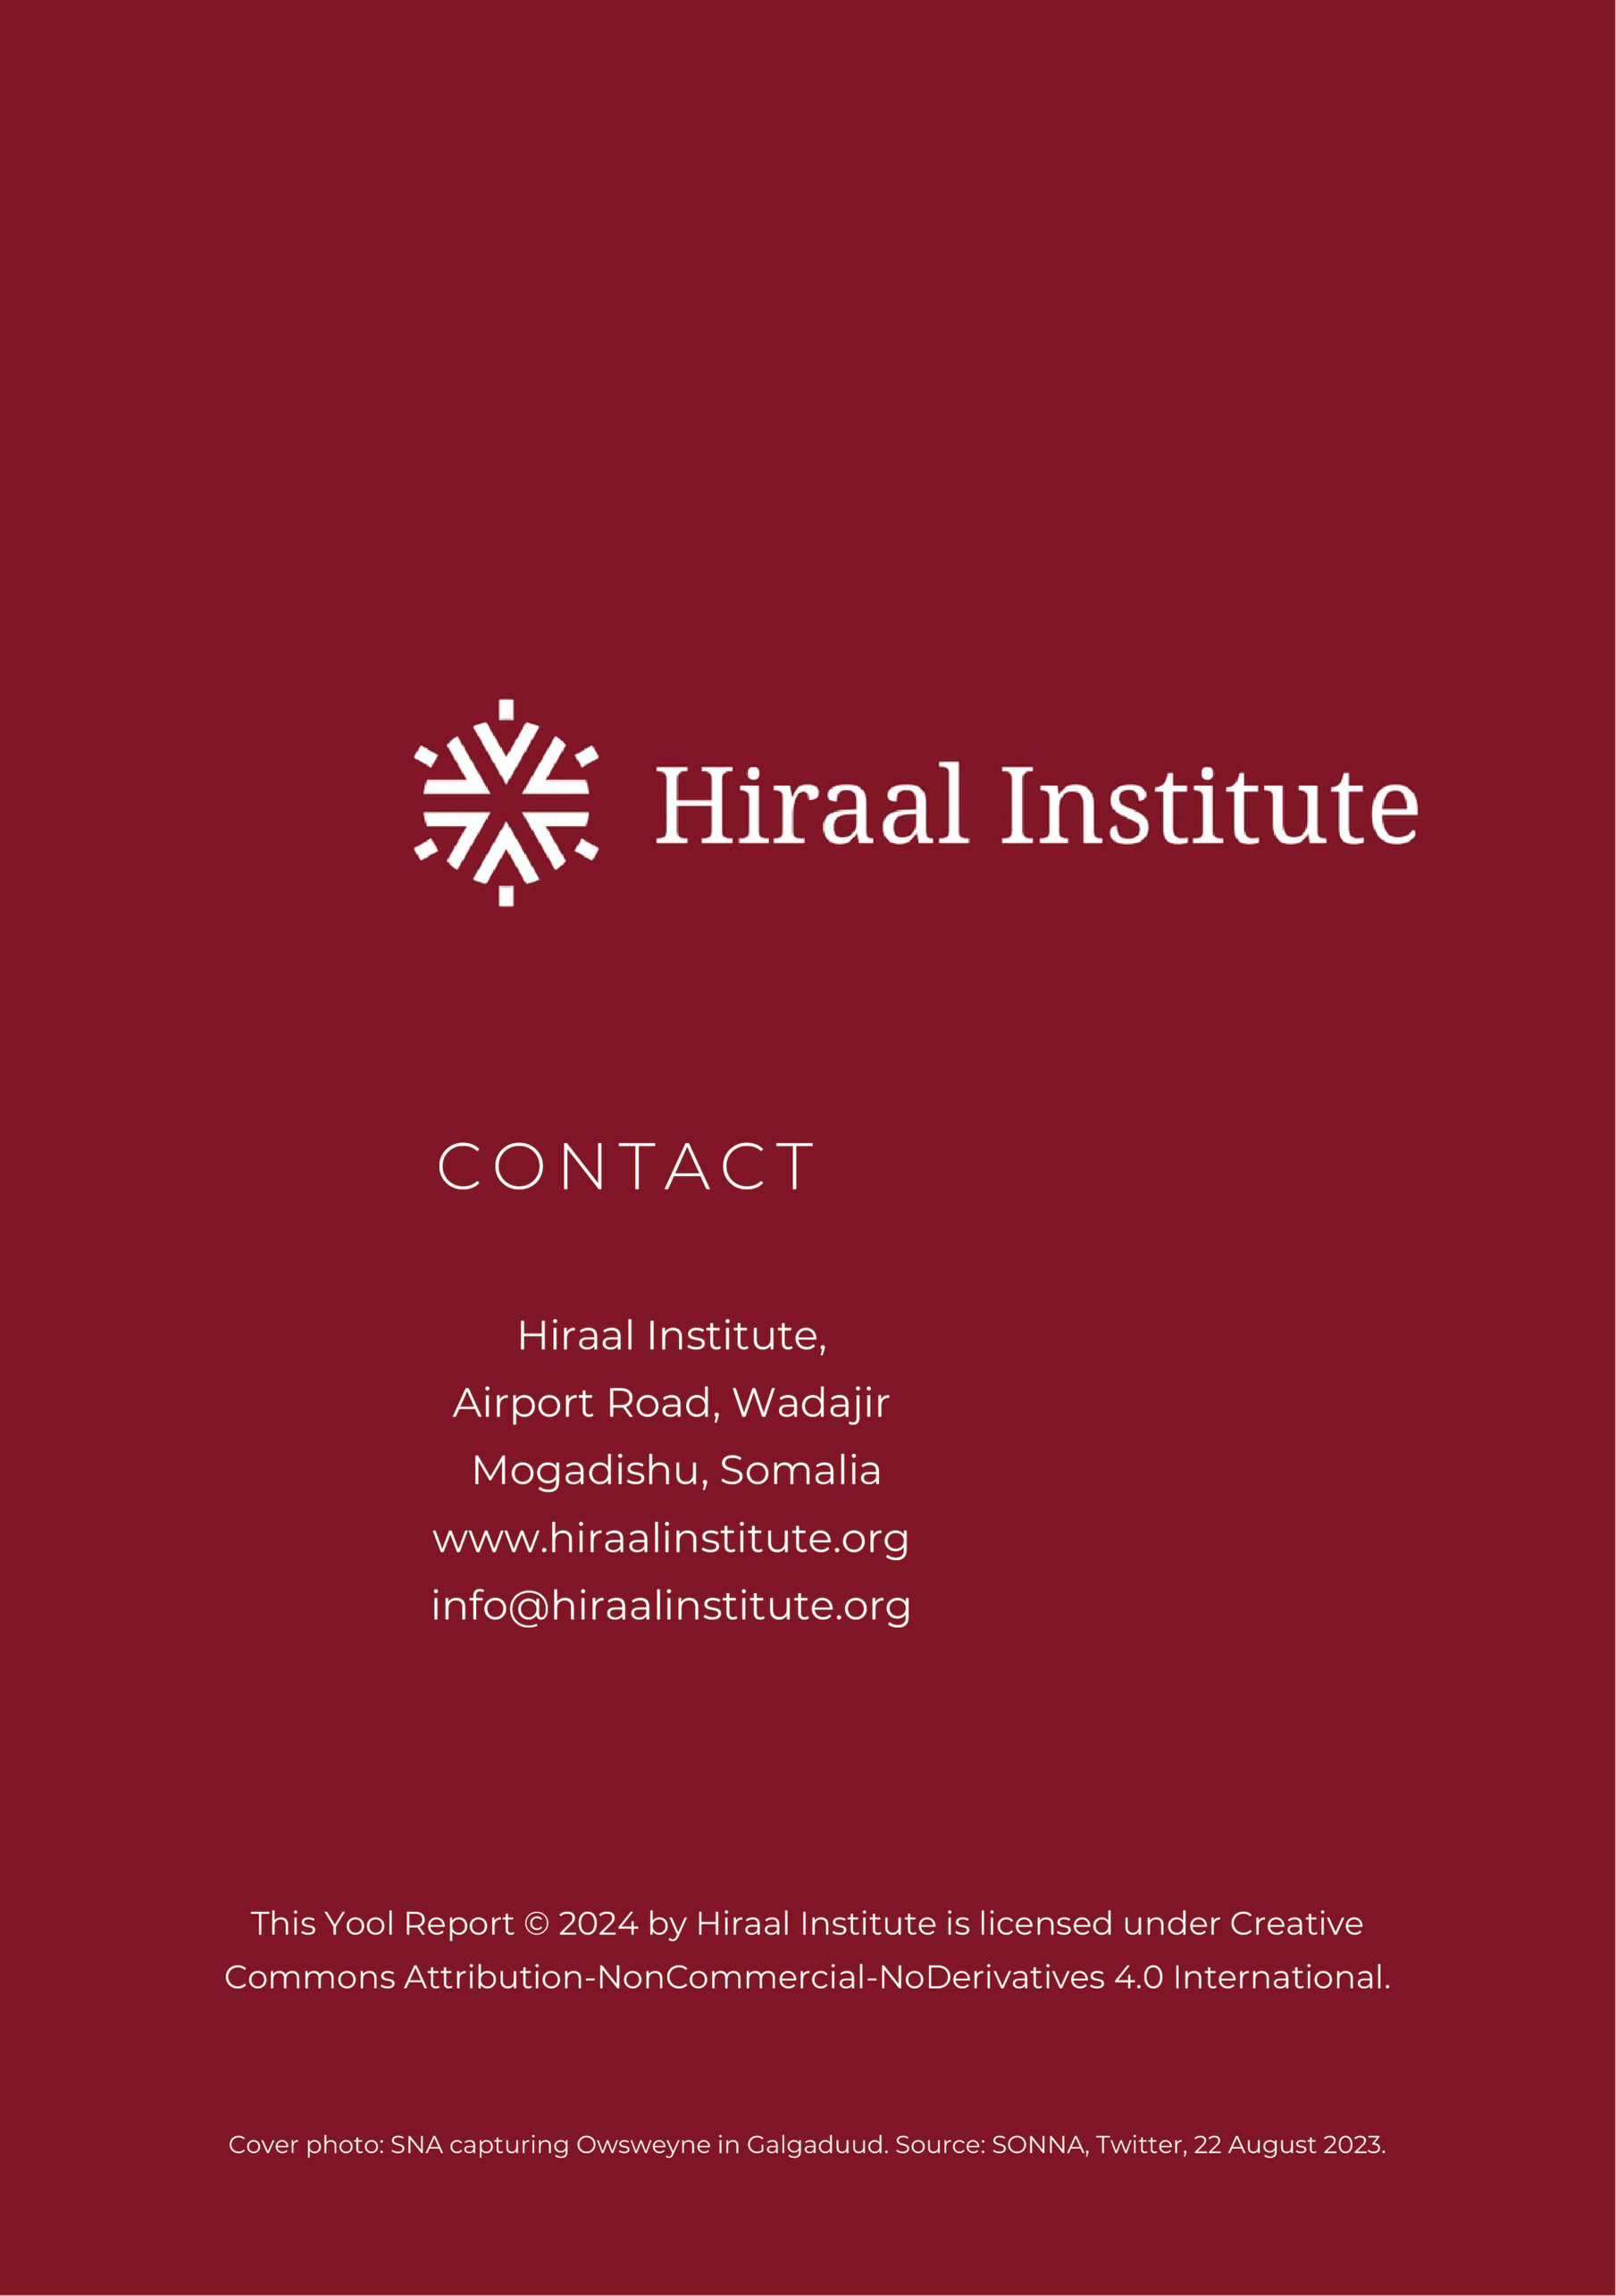

Mubarak, M. (2023) ‘Military offensive in Somalia could spark humanitarian crisis’. The New Humanitarian. Available at: https://www.thenewhumanitarian.org/opinion/2023/05/25/military-offensive-somalia-humanitarian-crisis (Accessed: 1 January 2024).
The Somali Digest. (2023) ‘Somalia’s Quiet Front: Mutiny, Monsoon, and Military Challenges’. Available at: https://thesomalidigest.com/somalias-quiet-front-mutiny-monsoon-and-military-challenges (Accessed: 31 January 2024).
Transportation businessman in Mogadishu, July 2023; Telecommunications and banking businessmen in Mogadishu, June 2023.
Telecommunications official in Mogadishu, August 2023.
Somali Guardian. (2023) 'Al-Shabaab spokesman accuses US of looting Somalia's wealth'. Available at: https://somaliguardian.com/news/somalia-news/al-shabaab-spokesman-accuses-us-of-looting-somalias-wealth (Accessed: 27 January 2024).
Ibid.
Telecoms source in Mogadishu, August 2023.
The Somali Digest. (2023) ‘Al-Shabaab imposes ban on Hormuud mobile money service in areas controlled by the group’. Available at: https://thesomalidigest.com/hormuud-mobile-money/ (Accessed: 31 January 2024).
The Somali Digest. (2024) ‘Hormuud Telecom Takes a Stand Against NISA’. Available at: https://thesomalidigest.com/hormuud-telecom-takes-a-stand-against-nisa/ (Accessed: 31 January 2024).
The Somali Digest. (2023) ‘Hormuud Attacked in Dayniile District’. Available at: https://thesomalidigest.com/hormuud-attacked-in-dayniile-district/ (Accessed: 31 January 2024).
The Somali Digest. (2023) 'Islamic State Somalia and Al-Shabaab Suspected After Two Hormuud Facility Attacks Near Mogadishu'. Available at: https://thesomalidigest.com/islamic-state-somalia-and-al-shabaab-suspected-after-two-hormuud-facility-attacks-near-mogadishu/ (Accessed: 31 January 2024)
The Somali Digest. (2023) 'Mogadishu IED Impact on Local Businesses'. Available at: https://thesomalidigest.com/mogadishu-ied-impact-on-local-businesses/ (Accessed: 31 January 2024).
The Somali Digest. (2023) ‘Al-Shabab CCTV Clash: Surveillance Battle in Mogadishu’. Available at: https://thesomalidigest.com/al-shabab-cctv-clash-surveillance-battle-in-mogadishu/ (Accessed: 31 January 2024).
The Somali Digest. (2023) ‘Al-Shabab Bombings in Mogadishu Following Stalled Operations’. Available at: https://thesomalidigest.com/al-shabab-bombings-in-mogadishu-following-stalled-operations/ (Accessed: 31 January 2024).
The Somali Digest. (2023) ‘Mogadishu Businesses Caught in Al-Shabab-Govt Crossfire’. Available at: https://thesomalidigest.com/mogadishu-businesses-caught-in-al-shabab-govt-crossfire/ (Accessed: 31 January 2024)
The Somali Digest. (2023) ‘Hormuud Under Attack’. Available at: https://thesomalidigest.com/hormuud-under-attack/ (Accessed: 31 January 2024).
Businessman in Mogadishu, July 2023.

